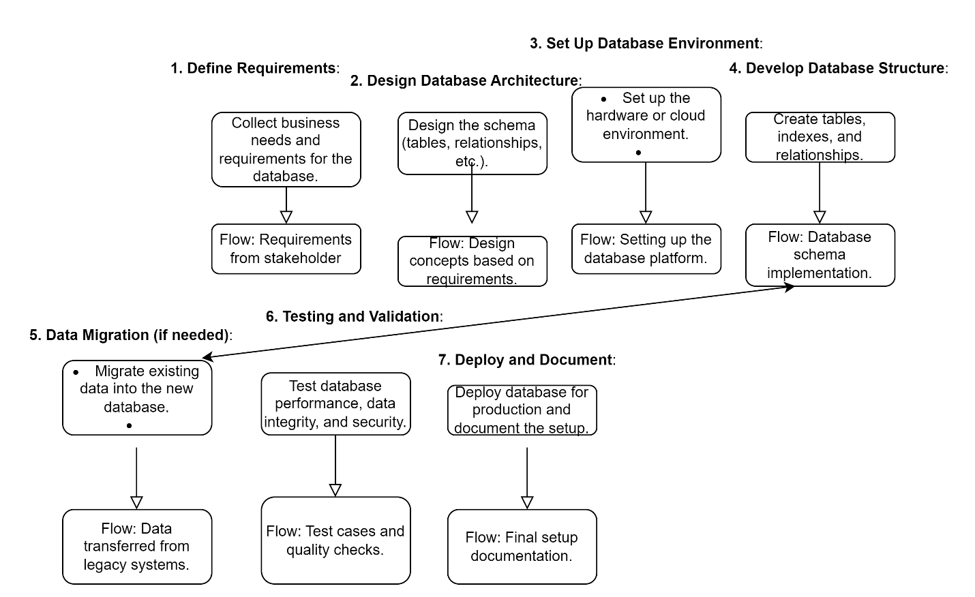

Estimated Average Lead Time:

|  |  |
| --- | --- |
| 1. **Define Requirements** | Time: 2-3 days |
| 1. **Design Database Architecture**: | Time: 1-2 days |
| 1. **Set Up Database Environment:** | Time: 1 day |
| 1. **Develop Database Structure:** | Time: 2-3 days |
| 1. **Data Migration (if needed):** | Time: 2-5 days |
| 1. **Testing and Validation:** | Time: 1-2 days |
| 1. **Deploy and Document:** | Time: 1 day |

Estimated Cycle Time: 13 days

|  |
| --- |
| **Elimination Waste**:  1 day can be shaved off by pre-set meetings with clients and providing them a template of past jobs. Data Migration can be eliminated if software programs are already set up.  **Workflow Orchestration:**  Data Migration can be removed if done on a previous job. Setting up the database can be done in conjunction with designing the architecture.   **Governance Modles:** No security protocols are in place. Database is left vulnerable without changing the past default passwords. |